**Dương Quân Bảo 2201040017 PCO.05**

**Overview**

The product is a website representing the Brazil Jiu-Jitsu club named CrowBJJ, built with HTML, CSS, JS, and the Bootstrap framework, the JQuery library. The icons are supported by Bootstrap Icons.

In terms of features, the project supports responsive on all devices, from small devices such as phones to large-screen devices including laptops, desktops, etc. At the same time, the project also supports dark mode with a dark tone. Light/dark mode customization can be done via a switch button on the navbar.

Overall, the project consists of 4 main pages: Home page (index.html), tuition page (tuition.html), store page (store.html), schedule page (schedule.html), and signup page (signup.html). All web pages have a navbar and footer.

1. **Homepage**

The homepage consists of 5 sections, in order: Banner with a link to the signup.html page, a section introducing the history and unique style of the martial art, a section introducing some outstanding instructors, a section displaying 3 featured photos of the club, a section introducing the club's sales page with a button linking to the store.html page.

1. **Tuition page**

The tuition page displays 3 available tuition packages with their respective privileges: 1-month, 6-month, and 1-year packages. Under each package, there will be a button that takes you to the signup.html page and pre-selects the corresponding package at the registration form by retrieving the parameter from the URI.

1. **Store page**

The store page displays 4 sets of martial arts uniforms, arranged in ascending order by price. Each product will be accompanied by a button to add the product to the cart. However, because there is no backend, the web will display a popup notification that the store is under maintenance whenever the "add to cart" button is clicked to replace.

1. **Schedule page**

The schedule page includes 1 table (represented in an image file) of class schedule and a download button so that visitors can download if they want.

1. **Signup page**

The signup page includes a registration form that requires users to enter their name, email, phone number, and select the appropriate registration package. If the user leaves blank or enters the wrong format of phone number or email (checked through regular expression), the register button will be disabled and cannot be clicked. If the user uploads a file image through the input element under the student proof section, the tuition will be automatically reduced by 15%. After successfully clicking register, a modal will be displayed to notify the successful registration and redirect the user back to the homepage.

1. **Navbar**

The navbar includes a logo, links to the 4 main pages, a light/dark mode customization button, and a link to the signup page.

1. **Footer**

The footer contains links to the club's social media pages, a club description, links to some main pages, and a column displaying contact methods including: address, email, phone number 1 and 2. The bottom of the footer has the website copyright mark.

**Results**

**Code structure**

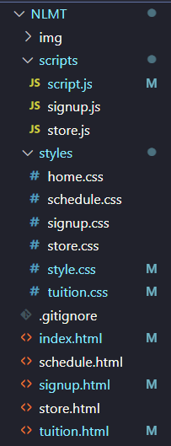

**Files content**

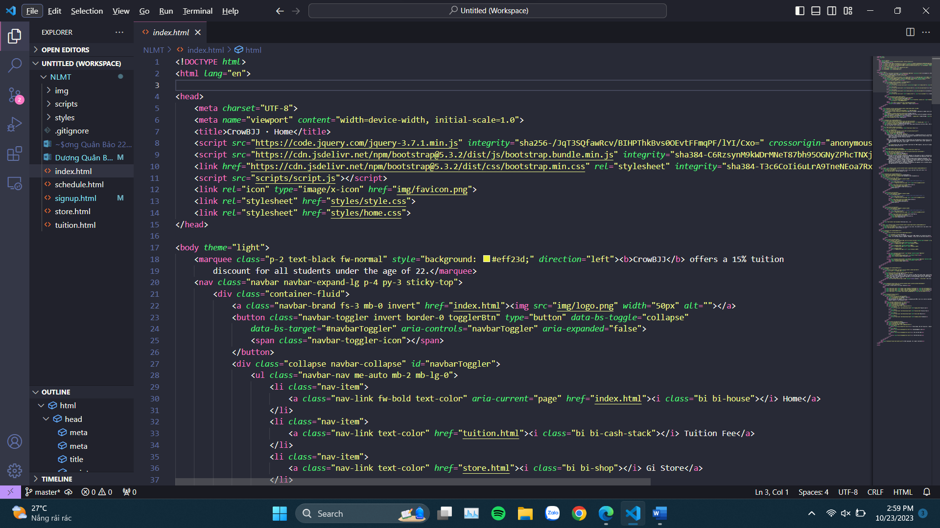

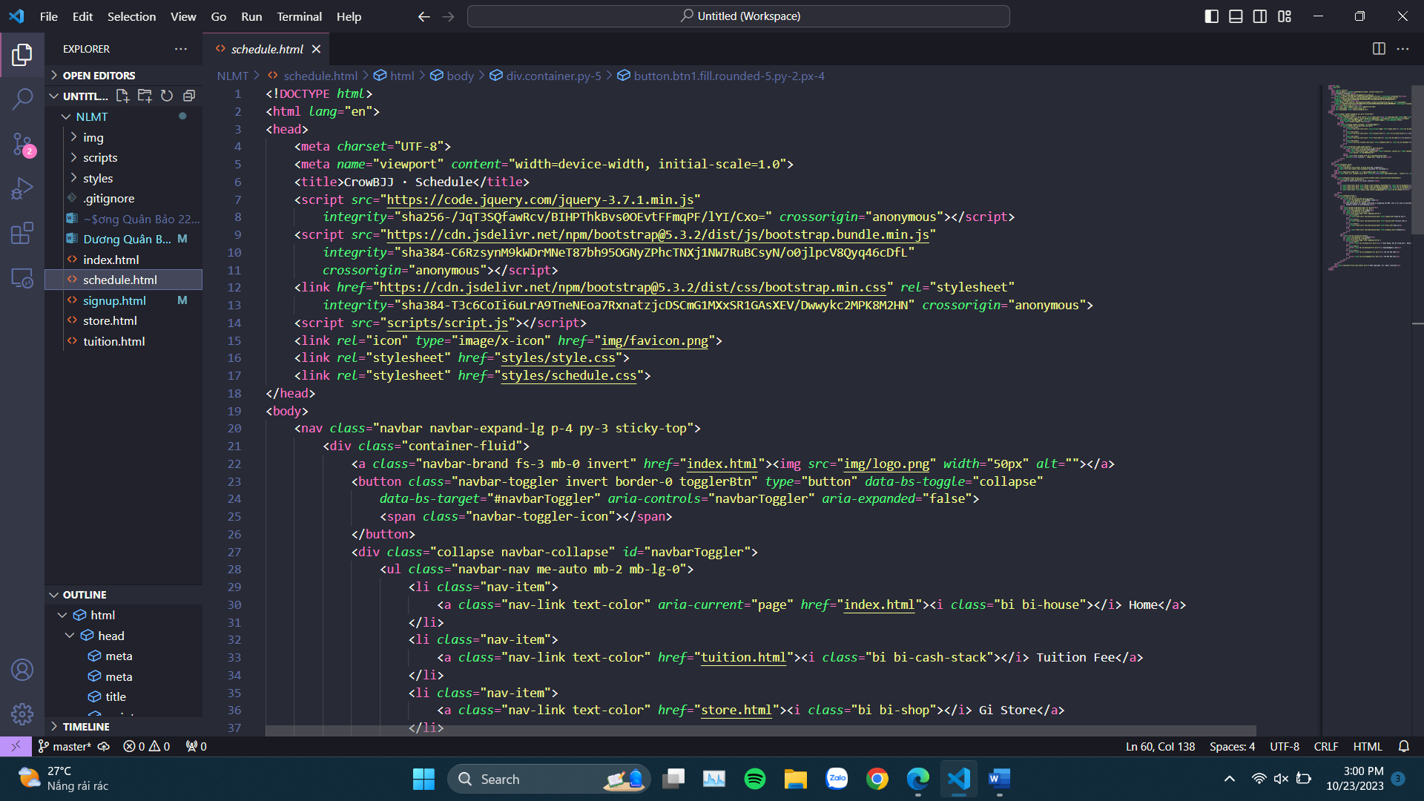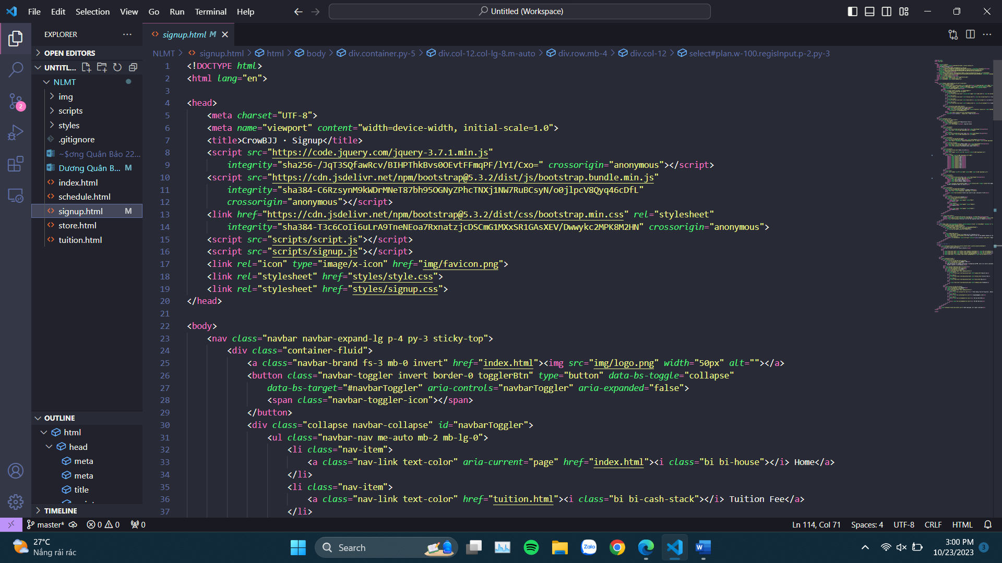

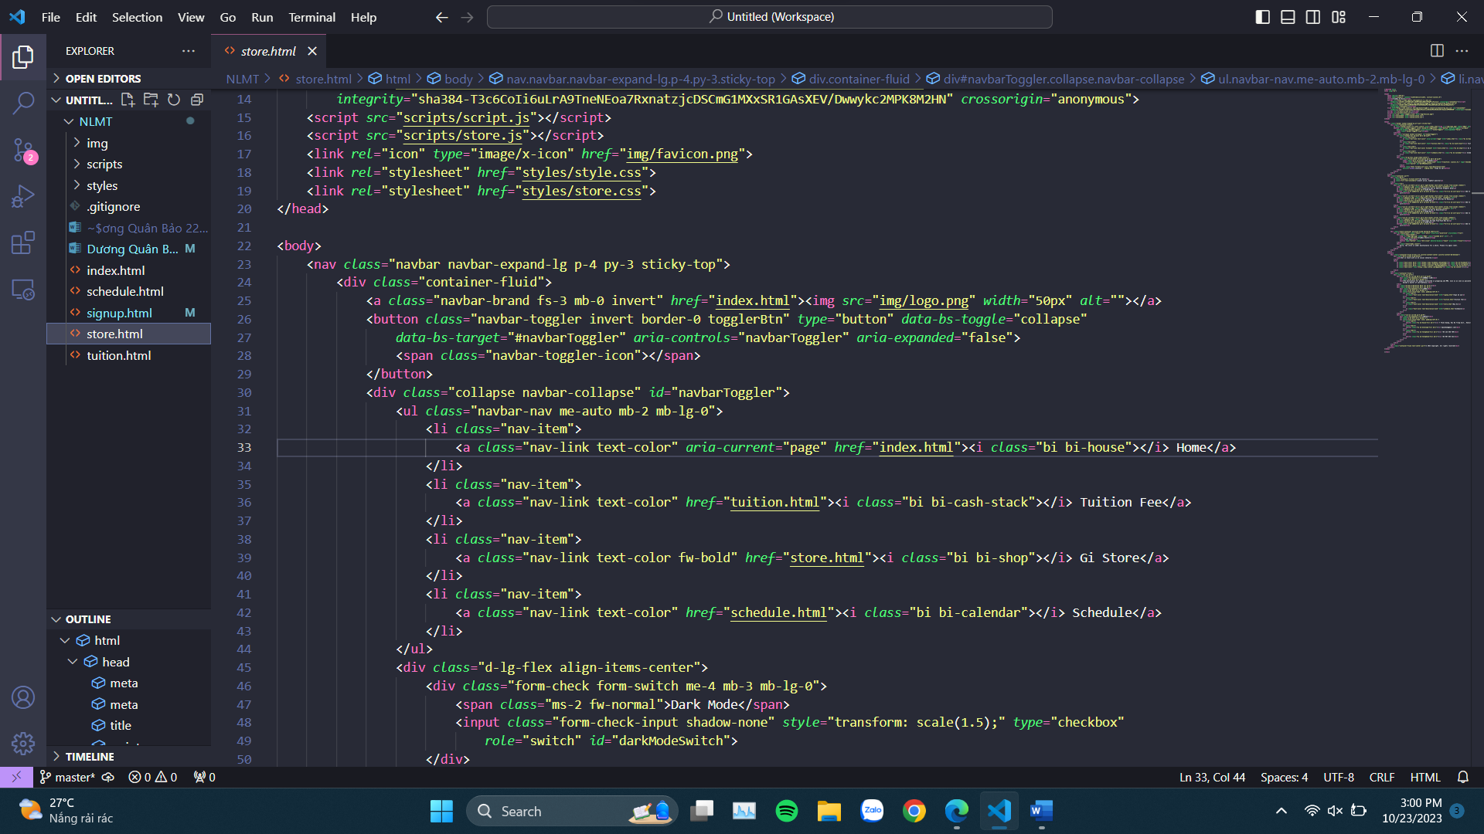

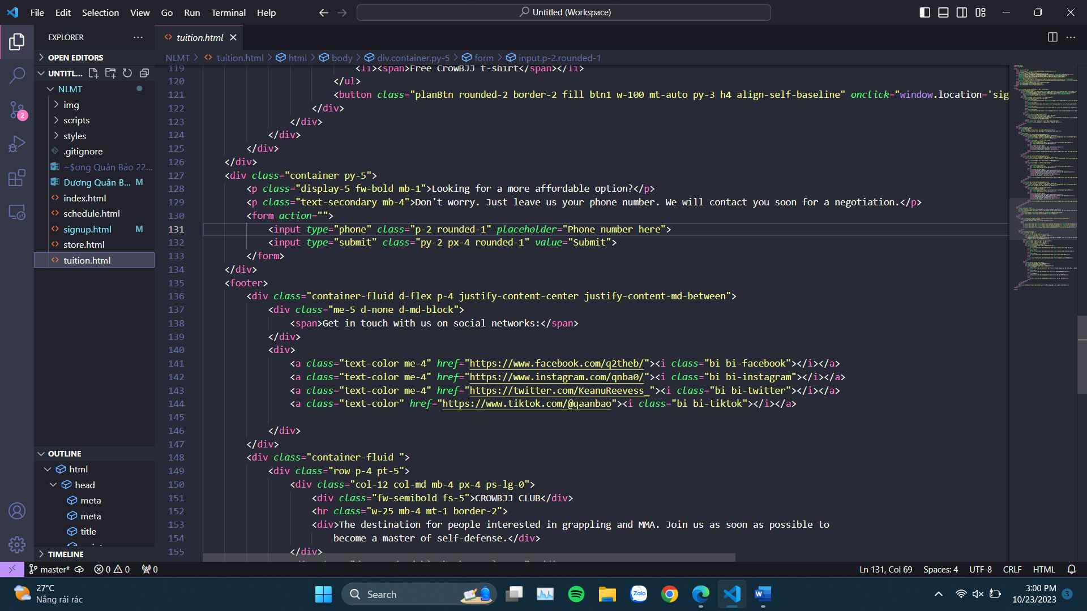

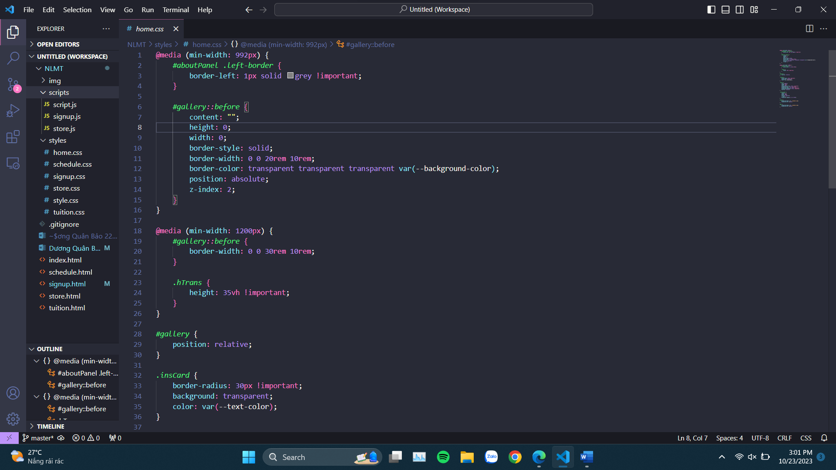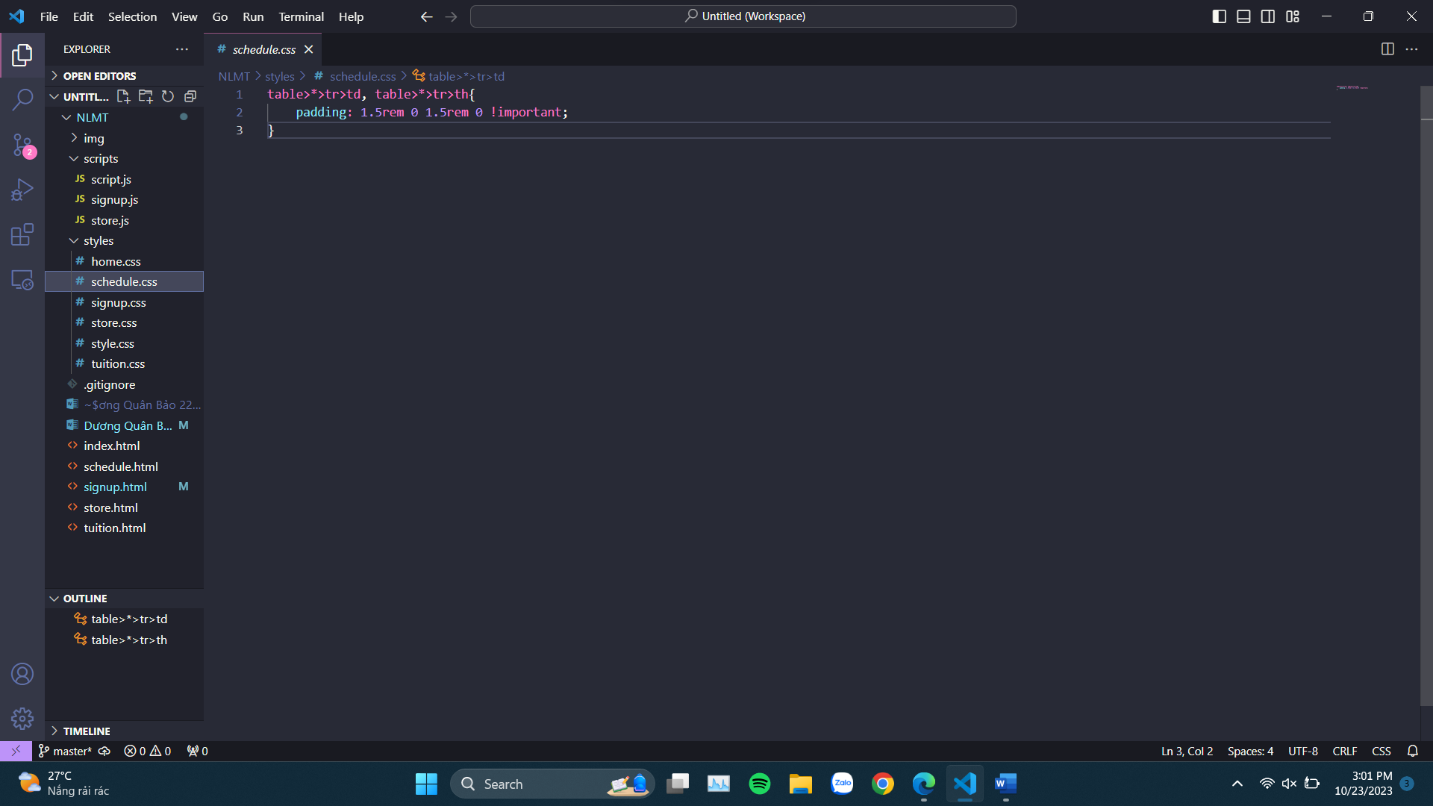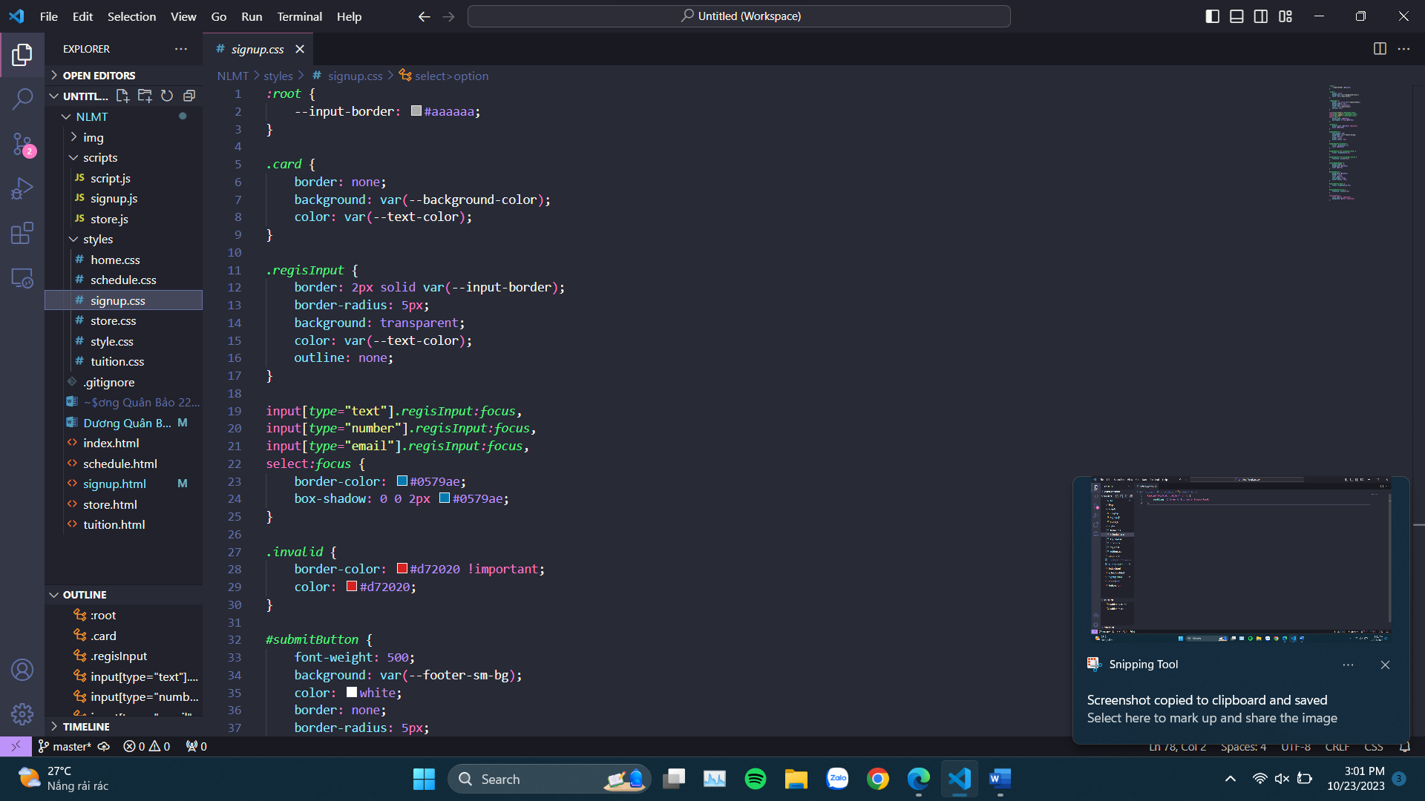

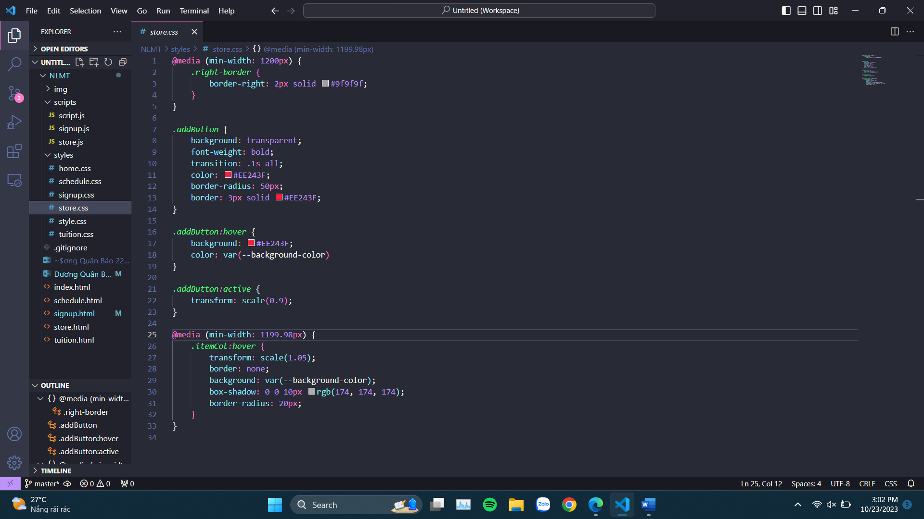

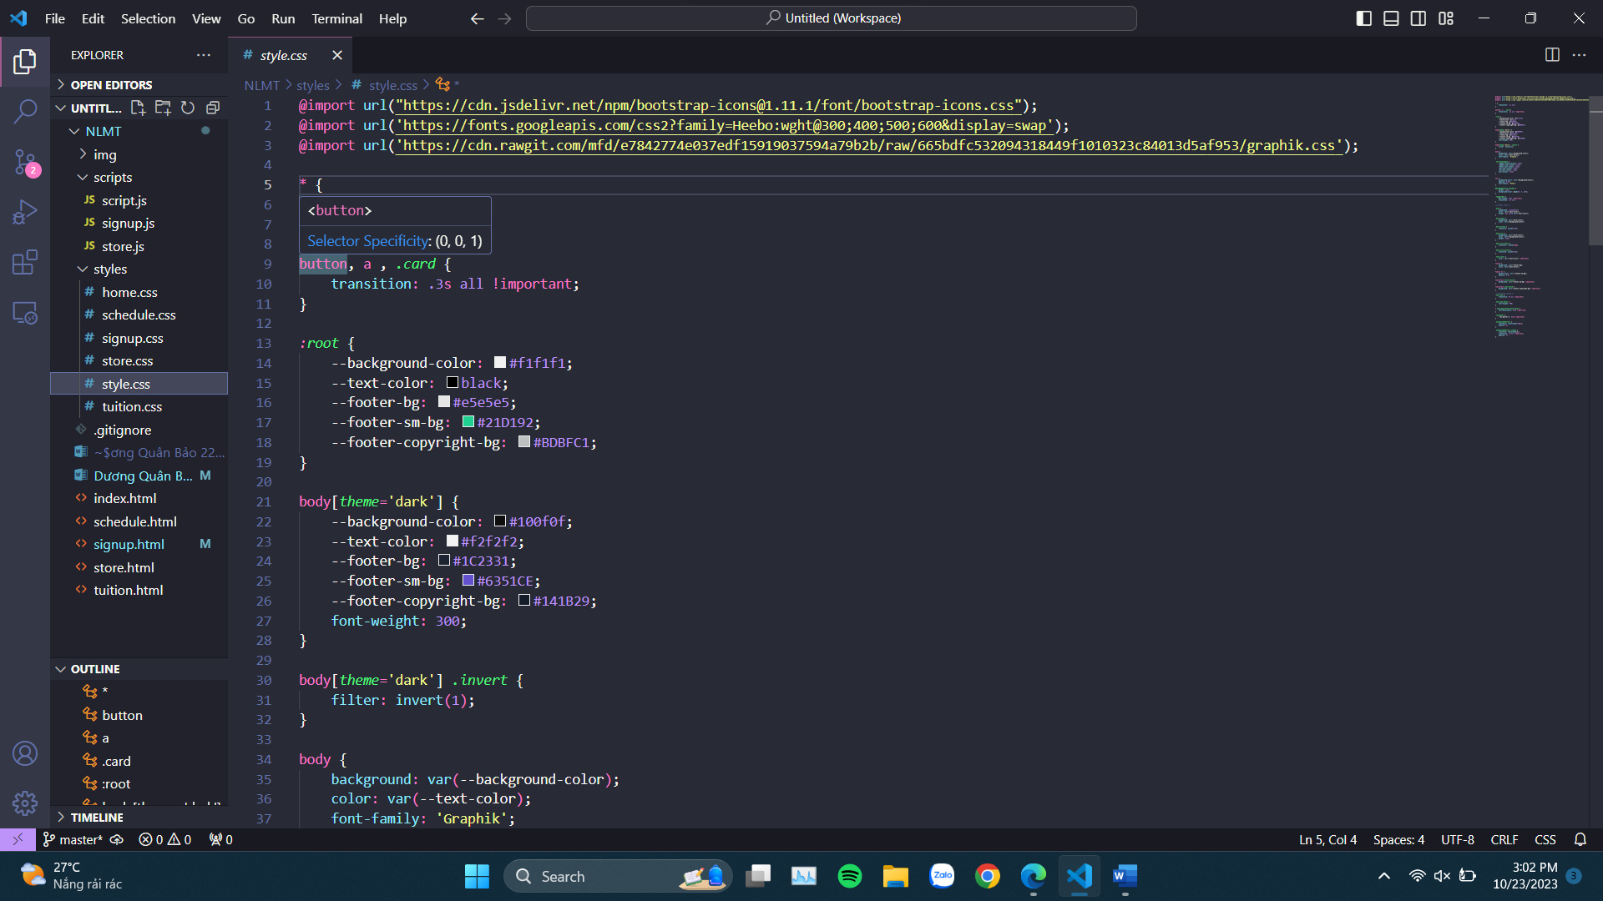

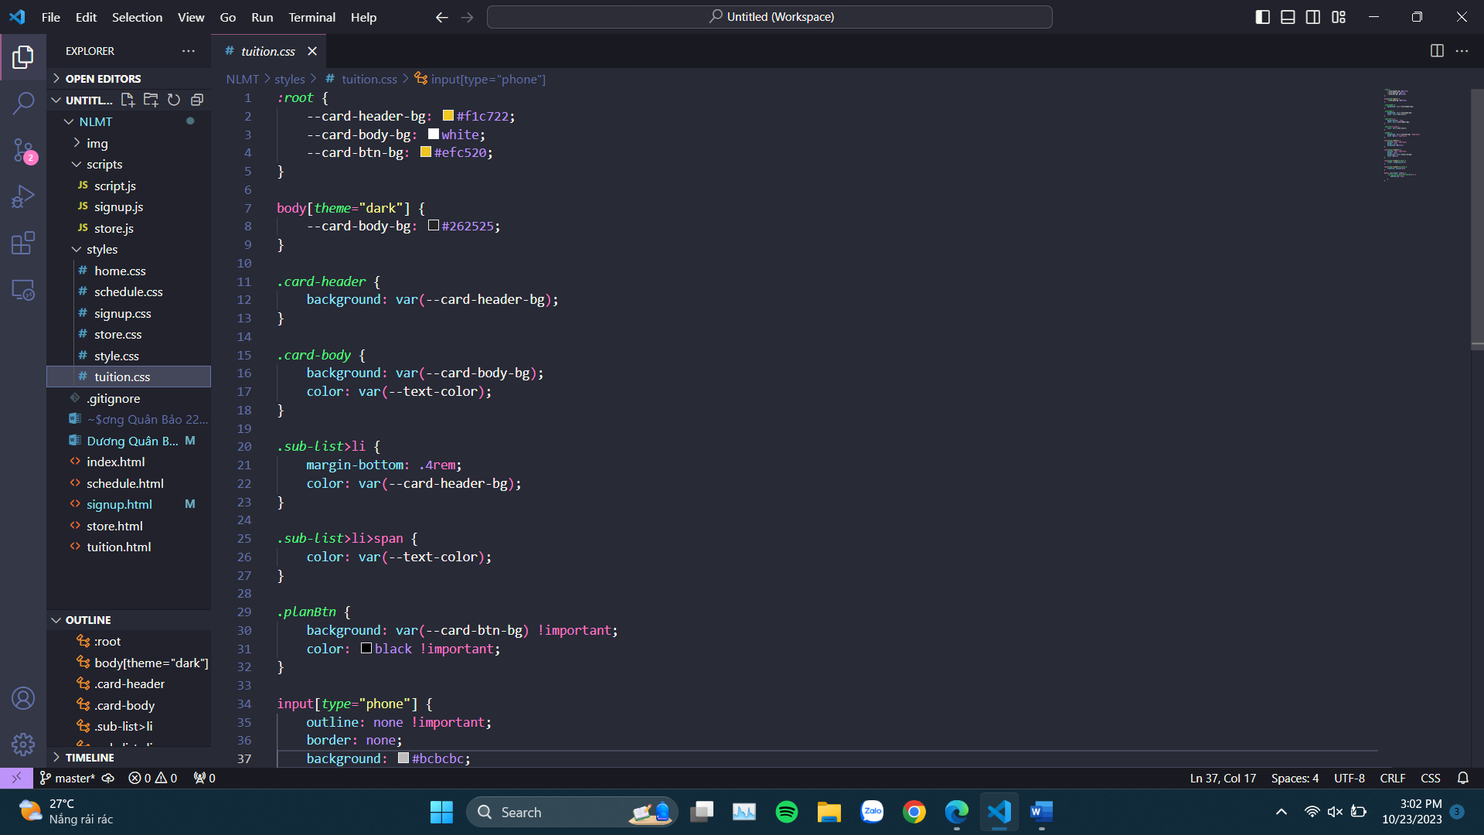

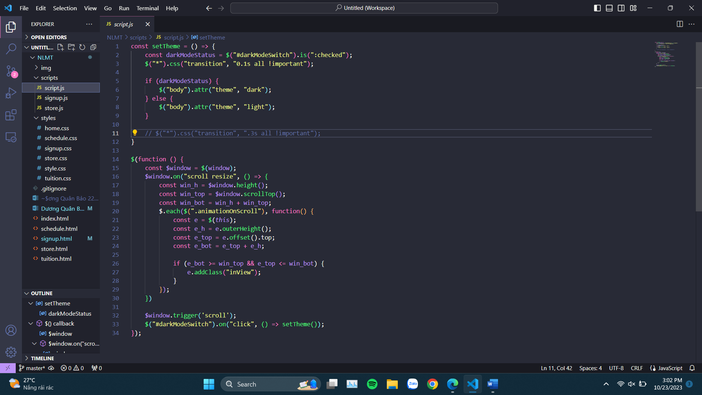

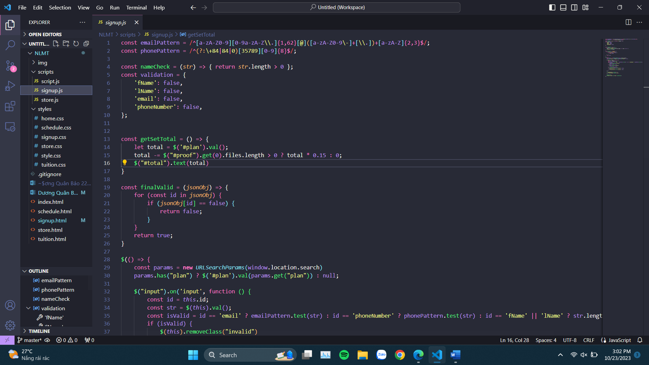

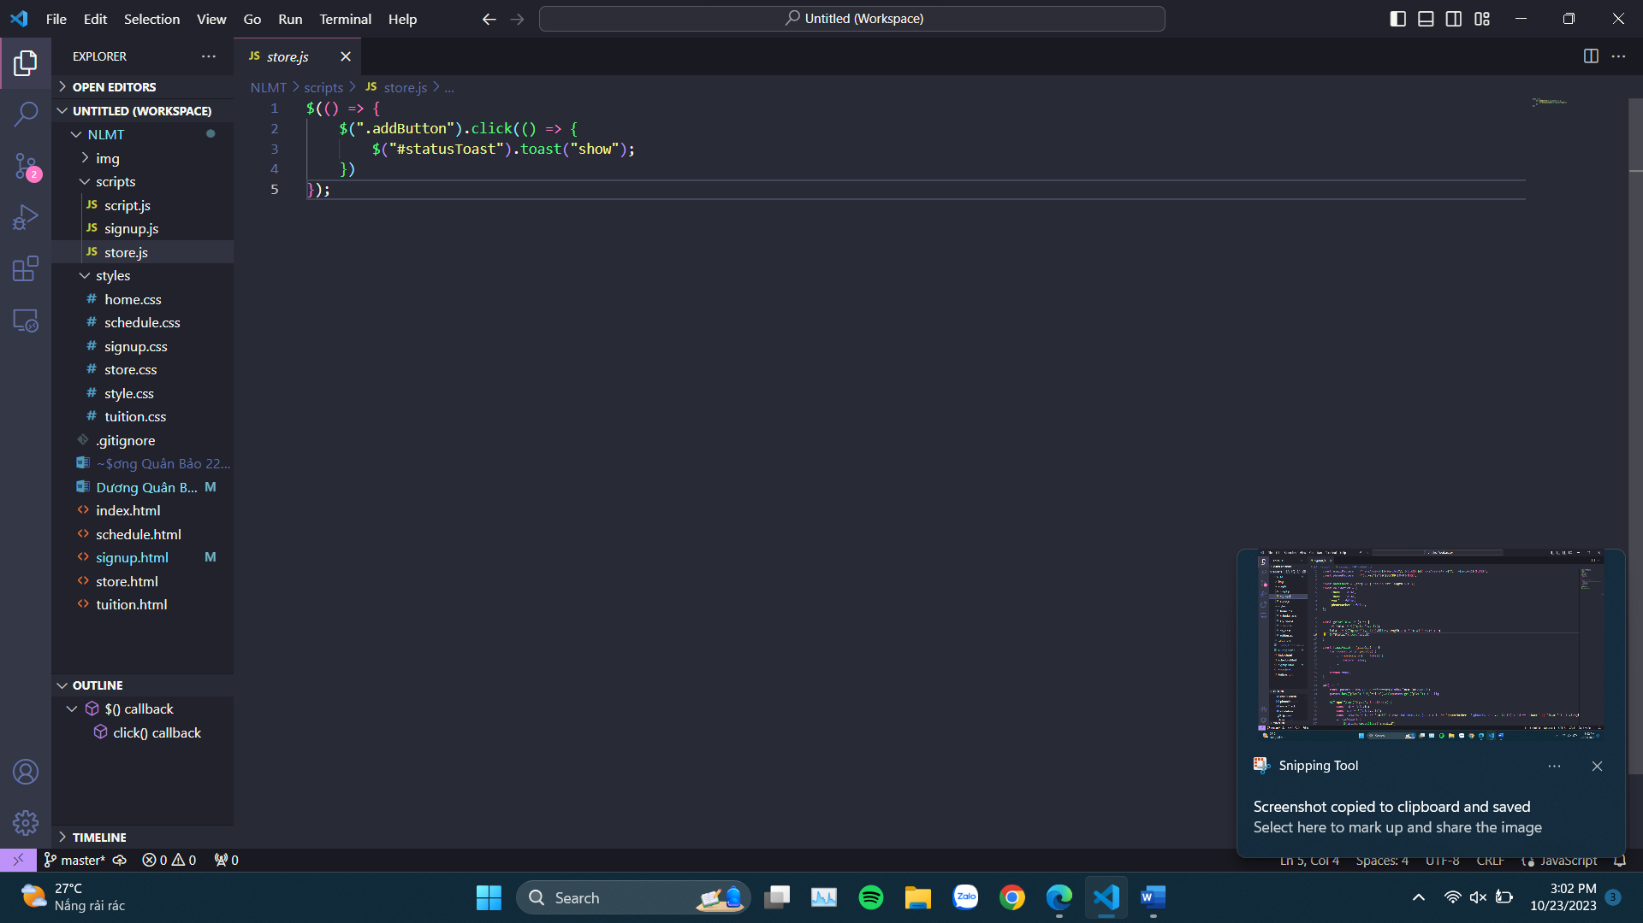

**Homepage (index.html) on 3 devices respectively PC, tablet, mobile phone**

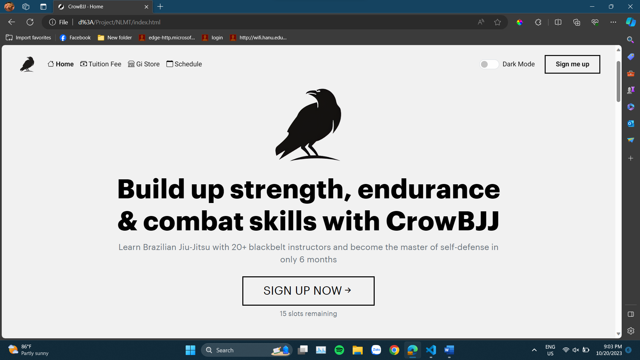

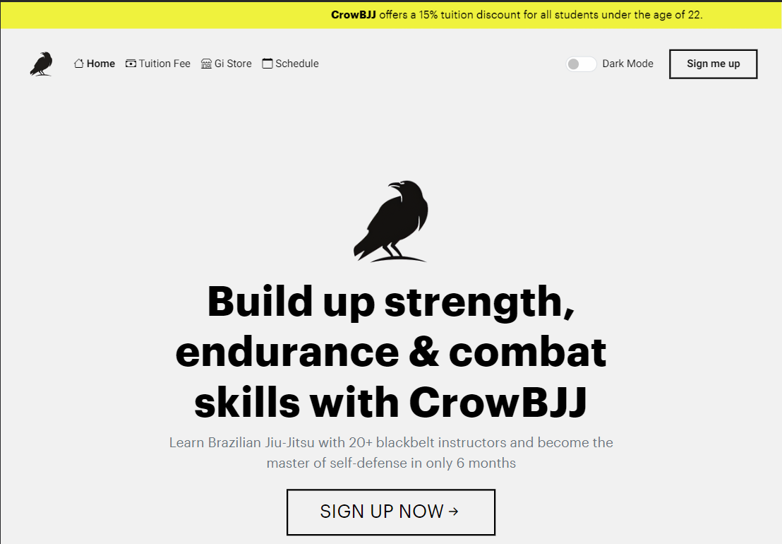



**Tuition page (tuition.html) on 3 devices respectively PC, tablet, mobile phone**

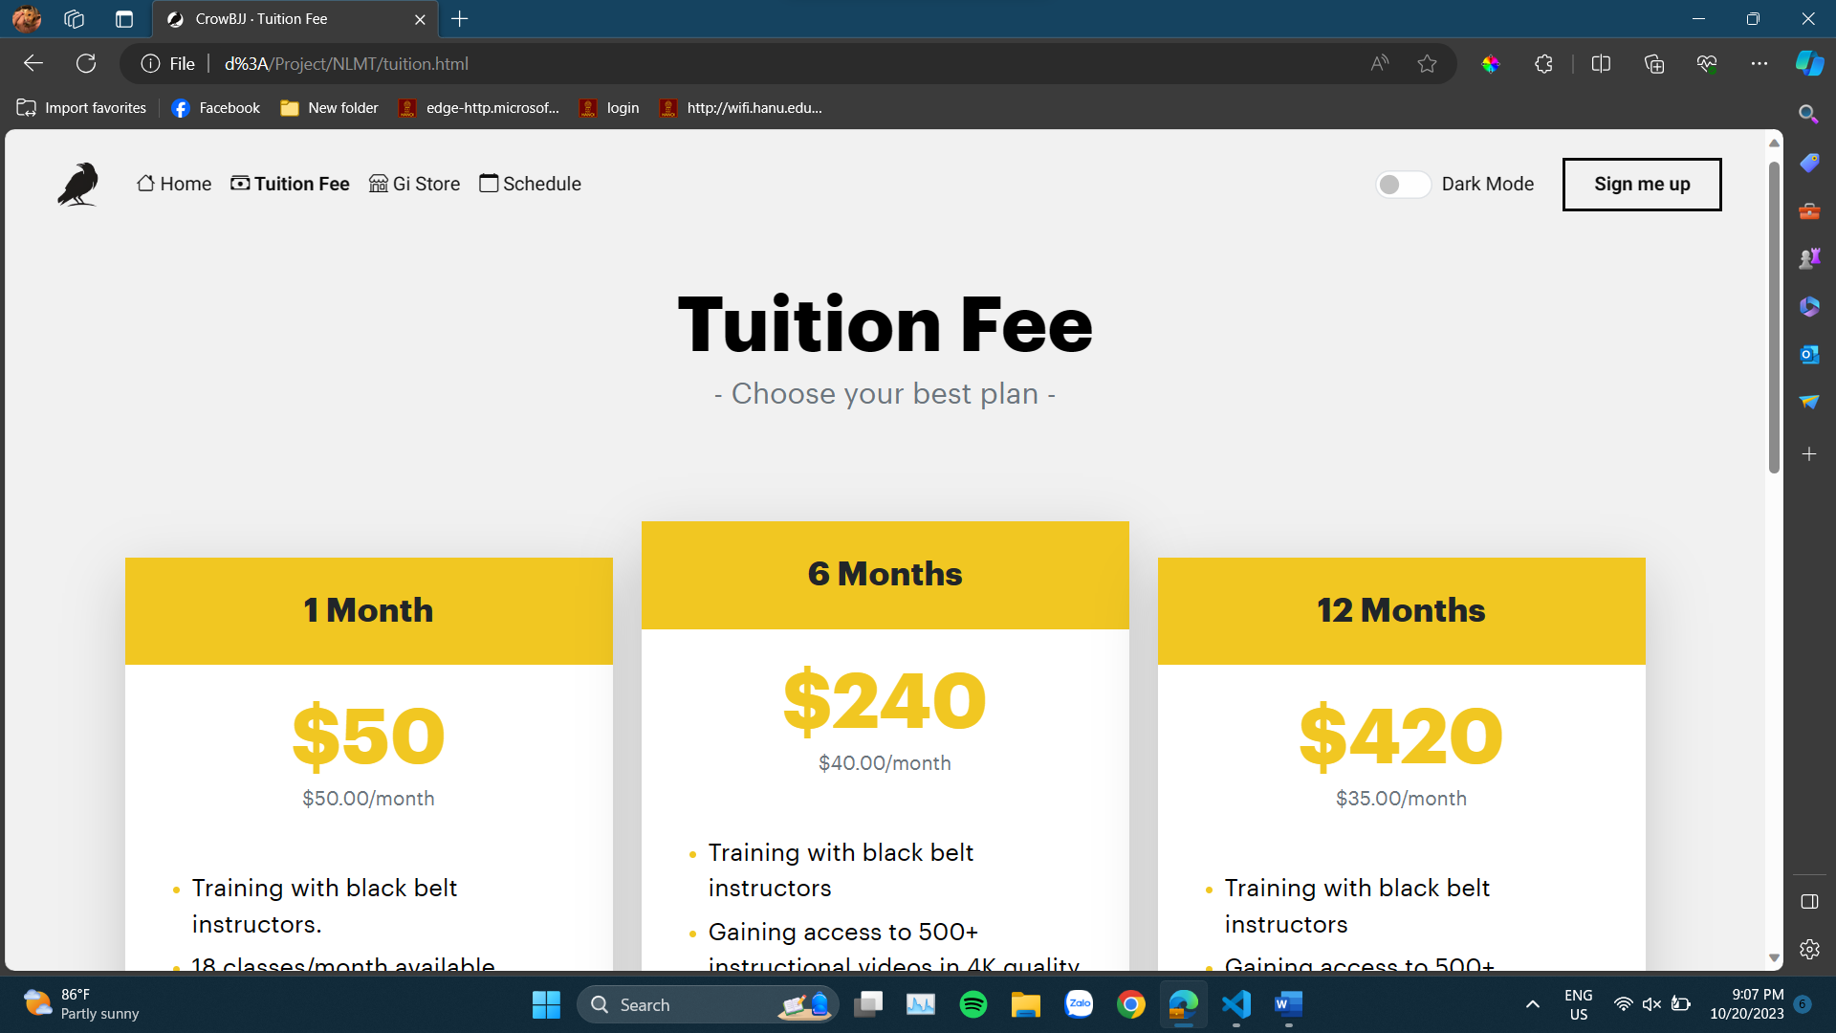





**Store page (store.html) on 3 devices respectively PC, tablet, mobile phone**

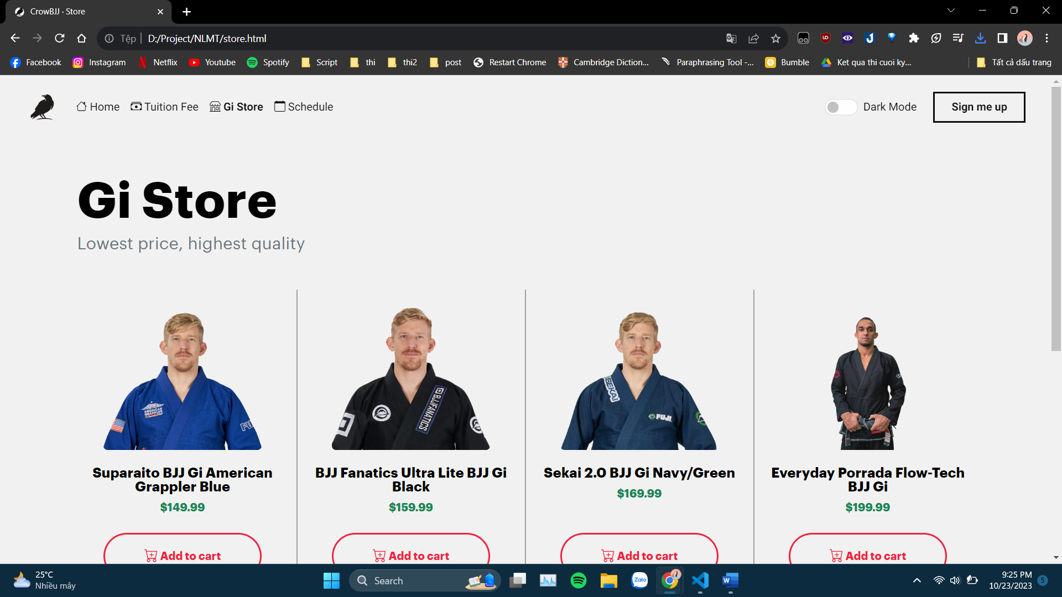

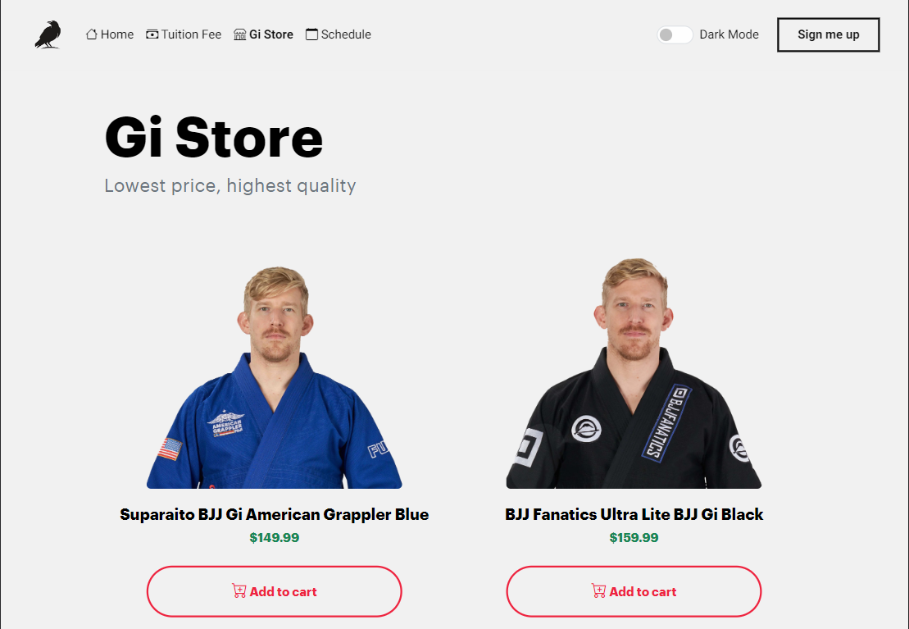

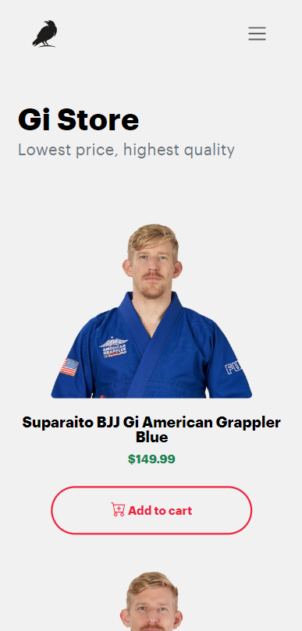

**Schedule page (schedule.html) on 3 devices respectively PC, tablet, mobile phone**

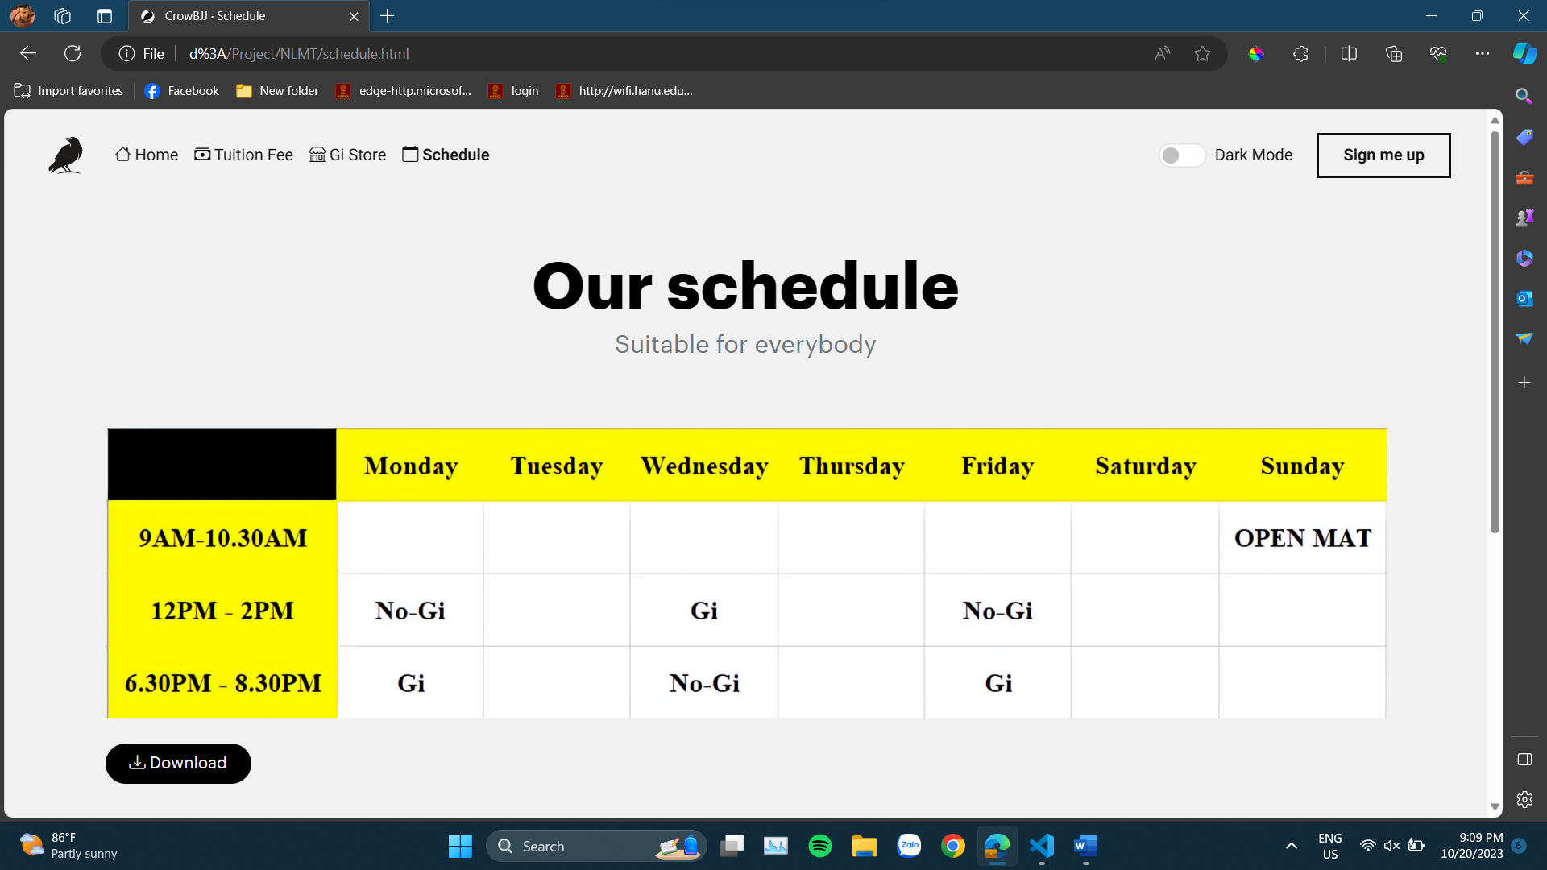

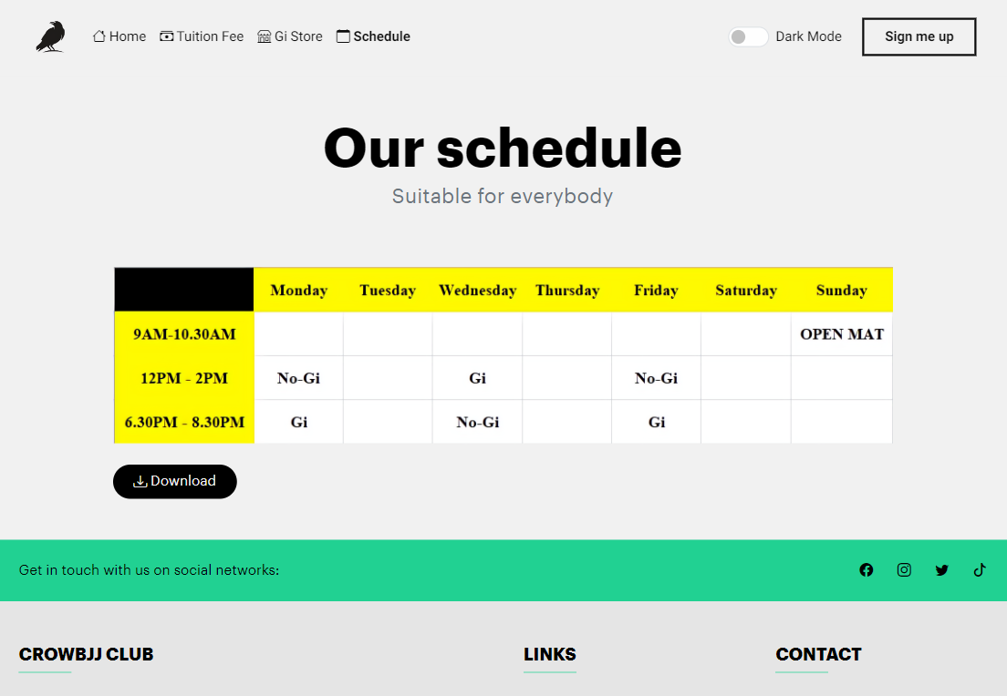

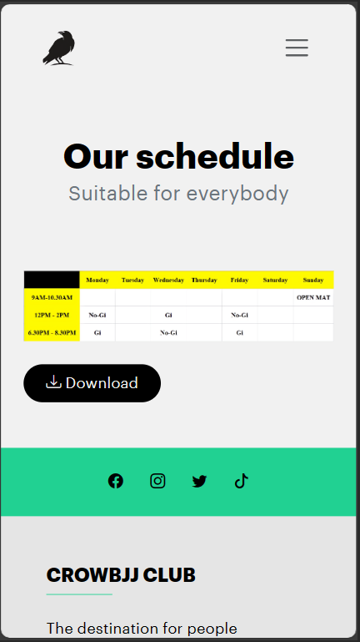

**Signup page (signup.html) on 3 devices respectively PC, tablet, mobile phone**

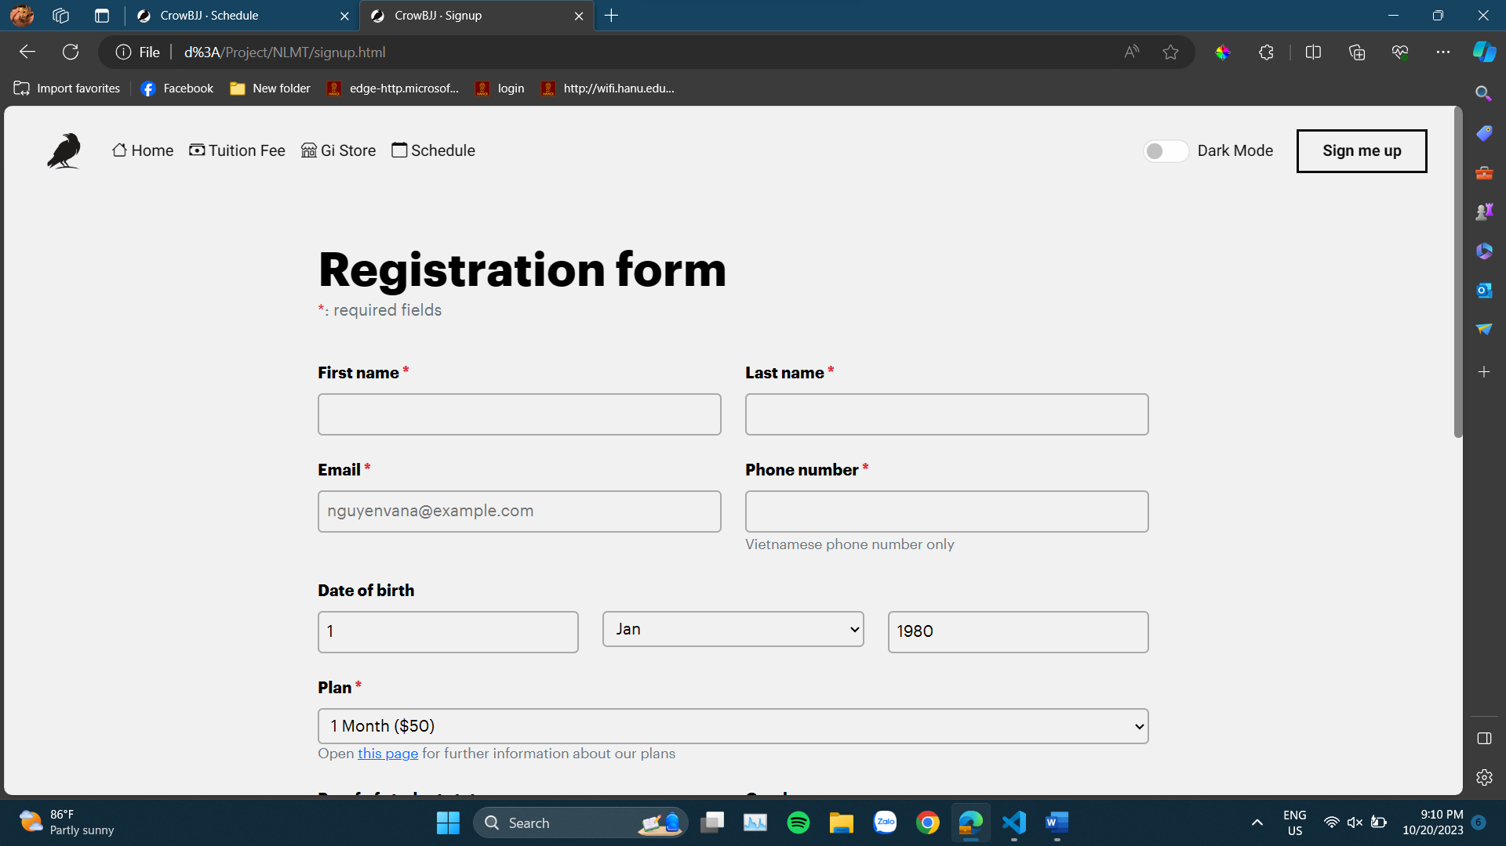

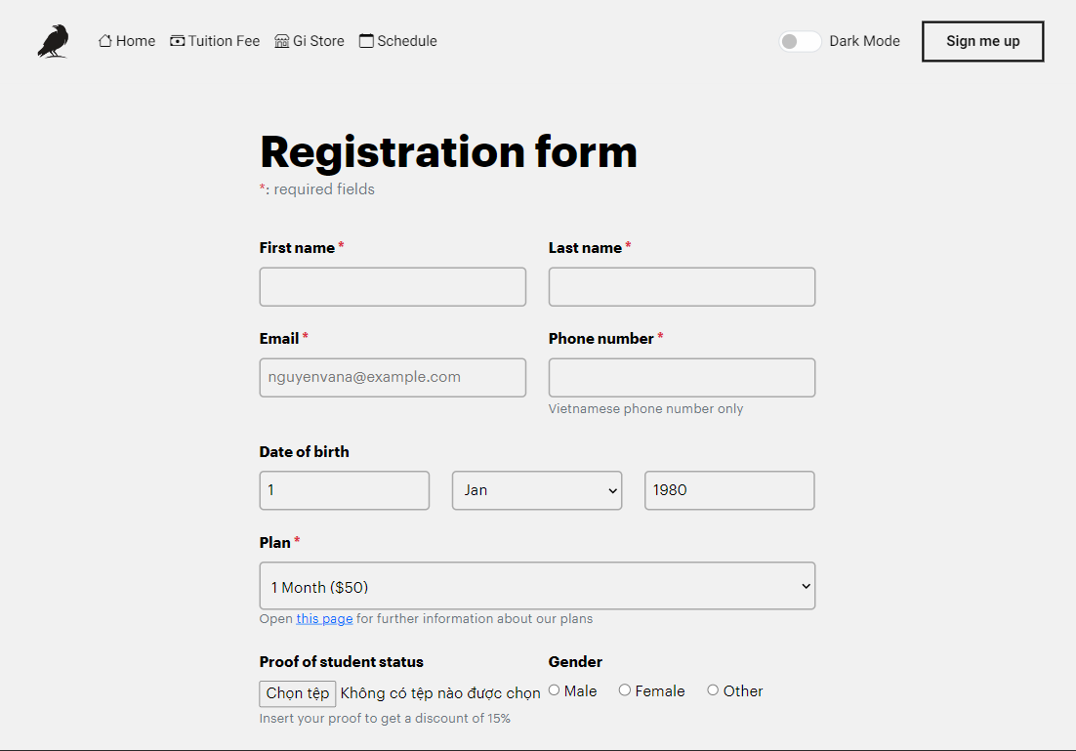

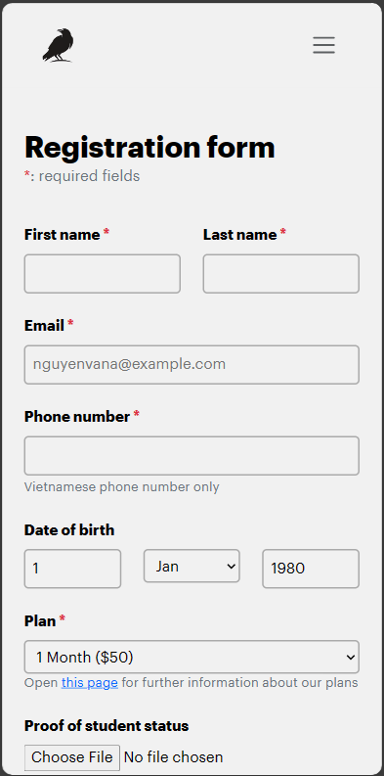

**Home page (index.html) with dark theme on PC**

